Fixed and Retractable warehouse :

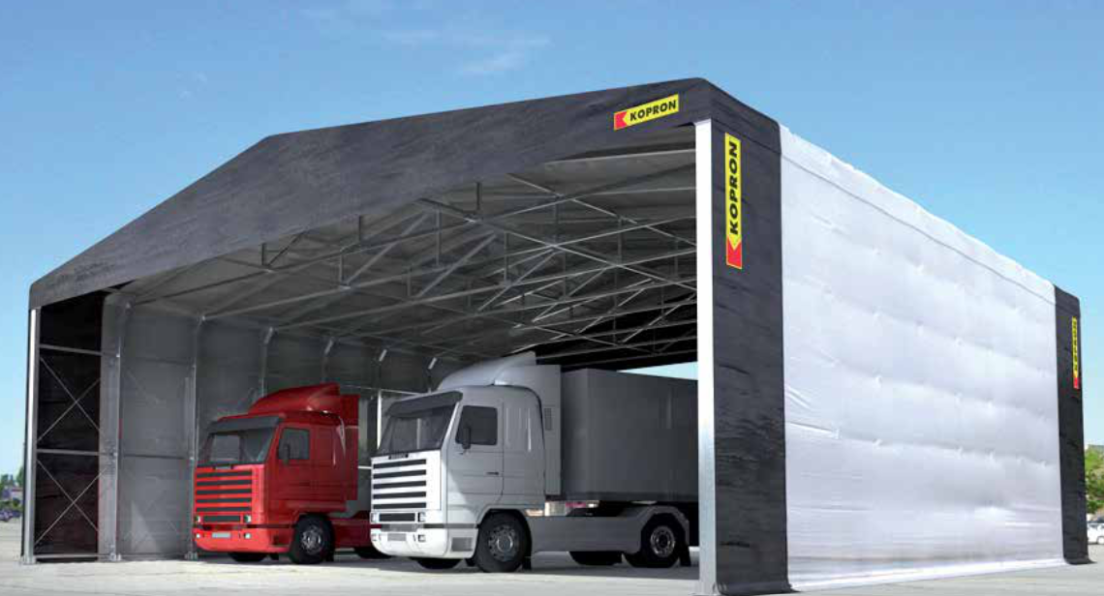

Types of Installation :
- Freees

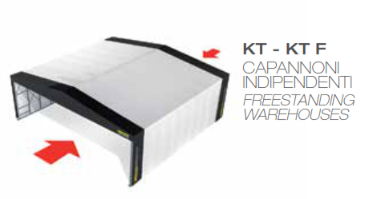

2)

